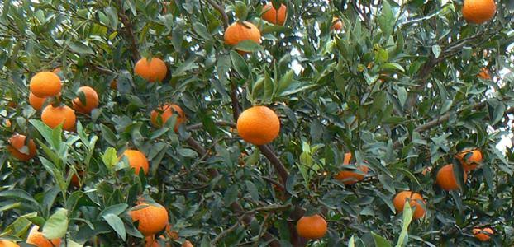

CWA Marmalade

Seville oranges make particularly good marmalade because their bitter juice stands up to all that sugar you need to make jam that’s not too sweet.

2 kg oranges
Juice of 1 lemon
2 litres water
White sugar
Remove zest from oranges with a peeler and cut into fine strips (no shortcuts here I’m afraid!)
Chop up oranges into small pieces and place in muslin bag (pith, pips and all).
Tie firmly
Put all ingredients except sugar into a big non-reactive pot and bring to boil.
Simmer for 1 hour with lid slightly ajar (liquid will reduce by about half)
Cover pot and leave overnight.
Next day squeeze muslin bag out (as much as you can), then discard bag.
Weigh how much liquid you have as you will then need same weight in sugar (for this recipe about 2kg sugar)
Bring liquid back to boil and add warmed sugar (you can do this by microwaving for about 5 mins).
Stir until sugar is all dissolved. Boil briskly for 5-10 mins until it reaches setting stage (test as you go or about 105 degrees if you have a thermometer)
Skim top with a spoon as you go to ensure a clear jelly.
When ready to bottle, leave for about 10 mins before bottling - this will ensure peel is distributed in jar
Bottle in sterilised jars.

